23

Software Requirements Specifications

Group 20

1 Introduction 4
1.1 Purpose 4
1.2 Scope 4
1.3 Definitions, Acronyms, and Abbreviations 5
1.4 References 5
1.5 Overview 6
2 General Description 6
2.1 Product Perspective 6
2.2 Product Functions 6
2.3 User Classes and Characteristics 8
2.4 General Constraints 9
2.5 Assumptions and Dependencies 9
2.6 Operating Environments 10
2.6.1 Client Environment 10
2.6.2 Server Environment 10
3 Specific Requirements 11
3.1 Functional Requirements 11
3.1.1 User Management 11
3.1.2 Class List Management 11
3.1.3 Application Round Management 11
3.1.4 Student Dashboard 11
3.1.5 Group Allocation 12
3.1.6 Notification System 12
3.2 Performance Requirements 12
3.2.1 Usability 12
3.2.2 Performance 12
3.2.3 Security 12
3.2.4 Reliability 13
3.2.5 Scalability 13
3.2.6 Maintainability 13
3.2.7 Compatibility 13
3.2.8 Data Integrity 13
3.3 Design Constraints 13
3.3.1 Standards Compliance 13
3.3.2 Hardware Limitations 14
3.4 Attributes 14
3.5 External Interface Requirements 14
Attribution 16
1. Aaron Flemming (Tallme2) 16
2. Hafidzuddin Rizqy Amirullah (Harvey/ZedArray) 16
3. Pinidu Himsara Kukule Liyanage (piniduliyanage-design) 17
4. Charles Jasper Cope (charlesjcope) 17
Agile 18
1. Meeting with Client 18
2. Regular Communications 18
3. Progress tracking 19

Project - Capstone Group Allocation System (CGAS).

1 Introduction

1.1 Purpose
The purpose of this Software Requirements Specification (SRS) is to provide a detailed description of the functional and performance requirements for the Student Project Application and Group Allocation System. This document defines the system’s behaviour, inputs, outputs, constraints, and performance specifications required to support the application and allocation process for student project units.

The intended audience of this document includes:

- Software developers responsible for the design and implementation of the system
- The project supervisor and unit coordinator responsible for overseeing and administering the project allocation process
- System testers are responsible for validating system behaviour
- Future stakeholders, including system administrators, IT support personnel, and maintenance developers responsible for the ongoing operation, support and enhancement of the system

This document serves as a reference for the design, development, testing, and maintenance of the system.

1.2 Scope
The software product to be developed is the Capstone Group Allocation System (CGAS).

The system is designed to support project-based units including - ISAD3000, WORK3008, and ICTE3002

The system will enable unit coordinates to manage student applications and allocate students into project groups across these defined units.

The software will provide the following capabilities:
- Uploading and managing class lists for project units
- Creating and managing application rounds with defined opening and closing dates
- Sending automated communications to students regarding application rounds
- Providing personalised dashboards for students to apply for projects
- Allowing students to upload supporting documents, such as resumes or CVs
- Displaying application status updates
- Supporting the allocation of students into project groups
- Linking student groups across different units where required

The primary objectives of the system are:
- To streamline the project application and group allocation process
- To reduce the manual administrative work performed by unit coordinators
- To provide clear visibility of application status for students
- To facilitate communication between students, supervisors, and coordinators
- To support cross-unit project collaboration where required

The system is intended for use by students and staff participating in project-based university units and will operate as a web-based application.

1.3 Definitions, Acronyms, and Abbreviations
Term | Definition
SRS | Software Requirements Specification
UC | Unit Coordinator
CGAS | Capstone Group Allocation System
Application Round | A defined period of time during which students may submit applications
Dashboard | A personalised user interface displaying relevant information and actions
MFA | Multi Factor Authentication

1.4 References
The following documents are referenced in this SRS:
- IEEE Standard 830-1984 - IEEE Recommended Practice for Software Requirements Specifications.
Institute of Electrical and Electronics Engineers (IEEE).
https://ieeexplore.ieee.org/document/278253
- Project Brief - Capstone Application System.
Curtin University.
Provided by the UC.

1.5 Overview
This SRS is organised into several sections that describe the system requirements in detail.
Section 1 provides an introduction to the document, including the purpose, scope, definitions, references, and document structure.
Section 2 provides an overview of the system, including its context, assumptions, and constraints.
Section 3 defines the system’s specific requirements, including functional and performance requirements.
This structure follows the IEEE 820 standard to ensure the requirements are clearly defined and traceable.

2 General Description

2.1 Product Perspective
The Capstone Project Allocation and Application Management System is a web-based application developed to aid the management of project applications and the allocation of groups for Curtin University courses, which include ISAD3000, WORK3008, and ICTE3002.

Currently, the application and project allocation processes are often carried out manually, using various tools, including spreadsheet applications, email, and others. This conventional method is often inefficient, difficult to monitor, and error-prone, especially for large groups of students.

With the proposed system, a centralised application and project allocation management system will be implemented, allowing Unit Coordinators to manage these processes within a single system. This is achieved through the system's capabilities, which enable the coordinator to upload the class list, create application rounds, and allocate students to groups.

For students, the system provides a personalised dashboard that allows them to submit their project applications and upload supporting documents, such as their CVs.

The system is a standalone system, meaning it can operate independently without integration with any other system within the university.

2.2 Product Functions
The Capstone Project Allocation System will enable the management of student project applications, as well as the formation of project groups, through the provision of various core functionalities.

Unit Coordinator
Supervisor/Client
Capstone Allocation System
Student
Upload class list, Create application, Allocate groups
Submit application, upload CV
View Status

Figure 1: Block Process Diagram of the Capstone Allocation System

The diagram illustrates the interaction of primary users with the Capstone Allocation System. The Unit Coordinators are responsible for uploading the class lists and managing the application process. The students apply through the system and upload the supporting documents. The system then processes the application and allows the coordinators to place the students in project groups.

The core functions that the Capstone Project Allocation System will perform include:

Unit Coordinator Functions:

- Upload the class lists for the supported units.
- Access a coordinator dashboard.
- Create application rounds with start and end dates.
- Send automated notifications to the students whenever an application round begins or ends.
- View the applications from the students.
- Allocate the students to project groups.
- Help students connect with each other from different units to form project groups.

Student Functions:

- Access a dashboard with a unique link.
- View the application rounds that are currently available.
- Make an application for a project.
- Upload any required documents, such as a resume.
- View the current status of the application.
- View the project group membership.
- Enter a contact email that the students can use to communicate with the project group members.

Optional System Functions:

- Provide a dashboard for academic supervisors to view each group, including relevant information pertaining to each group. (list of all members, project allocation, and client name)
- Provide a dashboard for the host organisation or the project client to view the project.
- Provide automated or semi-automated algorithms to help with the allocation of project groups.

2.3 User Classes and Characteristics

The system is designed for use by various user groups, each having different levels of technical expertise.

Unit Coordinators:

The Unit Coordinators are responsible for the project application and allocation process. They will use the system to upload class rosters, set up application periods, evaluate applications, and allocate the applicants to project groups. They are expected to have a moderate level of computer expertise and to be familiar with using administrative systems.

Students:

Student applicants for project groups will form the bulk of the user group for the system. They will use the system by accessing a personalised dashboard link. This will enable them to apply for project groups, upload the required documents, and keep track of their application status. Students are expected to have a basic level of computer knowledge and to be familiar with using web applications.

Supervisors (Optional):

Supervisors will use the system to view the details of the project groups they supervise. Their interaction with the system will be limited to viewing project and student details. They are expected to have a moderate level of computer knowledge and would be familiar with using computer systems for various tasks.

Clients / Host Organisations (Optional):

Clients or host organisations will use the system to view the status of the project/s they sponsor. Their interaction with the system will be limited to viewing project details.

Rationale for Including User Characteristics:

User characteristics play a crucial role in the design of the system because the user interface and overall system must be designed to accommodate the needs and capabilities of its users. Since some users may have limited technical expertise, the system must provide a user-friendly and intuitive interface.

2.4 General Constraints
There are several constraints that dictate the design and development of the system. They include:

- Student personal information and document upload security.
- Accessibility via standard web browsers.
- Ability to handle multiple academic units at once.
- Ability to create groups across units.
- Ability to upload documents, including CVs and résumés.
- Ability to handle large classes with many student applications.

These constraints will guide the design process in the next stages of development.

2.5 Assumptions and Dependencies
The development of this system is subject to a number of underlying assumptions, which are as follows:

- The Unit Coordinators will provide class lists with student details.
- The students will access this system through links received via email.
- The users will have access to the Internet.
- The system will only cater to units specified in the project brief.
- Supervisors and external clients may require access to project information as required by the project.
- The system may expand these underlying assumptions in the future to cater to other needs of the system.

2.6 Operating Environments
The Capstone Group Allocation System will operate as a web-based application accessed through standard web browsers. The operating environment must support reliable access for students, unit coordinators, supervisors, and host organisations, both on and off campus.

2.6.1 Client Environment
Devices:
- Desktop and laptop computers
- Tablets and smartphones

Operating Systems:
- Windows, macOS, and Linux for desktop and laptop devices
- Android and iOS for mobile devices

Web browsers:
Current versions of modern, standard-compliant browsers:
- Google Crome
- Microsoft Edge
- Mozilla Firefox
- Apple Safari

Network Requirements:
A stable internet connection is required to access the web application and to receive email notifications from the system.

2.6.2 Server Environment
Application server:
A web server capable of hosting the Capstone Allocation System web application (for example, Apache, Nginx, or an equivalent server platform).

Database server:
A relational database management system to store student records, user accounts, project information, applications, and group allocations.

Email services:
An email service to support automated email notifications sent by the system.

Security:
All communication between clients and the server shall occur over HTTPS to protect sensitive student and project data in transit.

3 Specific Requirements

3.1 Functional Requirements
The system shall provide the following core functionality to support the management of student project applications and group allocation.

3.1.1 User Management
- The system shall support multiple user roles, including UCs and students.
- The system shall optionally support additional roles, including administrators and host organisations.
- The system shall require all users to authenticate using a secure login process.
- The system shall implement role-based access control (RBAC) to manage permissions.
- The system shall restrict access to system features based upon the user’s assigned role.
- The system shall ensure that users can only access functions and data relevant to their role.

3.1.2 Class List Management
- The system shall allow UCs to upload class lists for supported units.
- The system shall process uploaded class lists to create student records.
- The system shall store student records within the system database.
- The system shall provide UCs with a dashboard interface.
- The system shall display the following information within the UC dashboard:
  - Enrolled student information.
  - Application round information.
  - Group allocation information.

3.1.3 Application Round Management
The system shall allow UCs to create and configure application rounds. Each round shall include:
- A defined start and end date.
- Automated communication messages when the round opens or closes.
- Eligibility checks to determine which students may apply.

The system shall notify eligible students when a round becomes active.

3.1.4 Student Dashboard
Each student shall be provided with a personal dashboard accessible via a unique link. The dashboard shall allow students to:
- View currently open application rounds.
- Submit project applications.
- Upload supporting documents such as resumes or CVs.
- Track the status of submitted applications.
- View group membership information is assigned to a project group.
- Specify a preferred contact email address visible to group members and supervisors.

3.1.5 Group Allocation
The system shall provide an interface that enables UCs to allocate students to group projects. The allocation interface shall include:
- Manual assignments of students to groups.
- Linking of students across multiple units.
- Display of group membership information to relevant users.

Automated allocation assistance may optionally be provided through grouping algorithms or methods.

3.1.6 Notification System
The system shall provide automated notifications to relevant users. Notifications shall include:
- Application round opening /closing.
- Application status updates.
- Group allocation updates.

Notifications shall be delivered via email or in-application messages.

3.1.7. File export
- Allow users to export data into a CSV format.
- Support the export of key datasets, including student records, applications, and group allocations.
- Ensure the exported CSV files are structured with appropriate headers and standardised formatting.
- Allow authorised users to export system logs.
- Include relevant metadata in export logs, such as timestamps, user actions, and system events.
- Restrict file export functionality based upon user roles and permissions.
- Ensure exported files are generated securely and made available for download.

3.2 Performance Requirements

3.2.1 Usability
The system shall provide a user-friendly web interface designed for both students and academic staff, with clear layouts, intuitive controls, and consistent labeling. Users shall be able to access their dashboard and core functions with minimal navigation, defined as reaching any primary feature within three clicks from the home page.

3.2.2 Performance
The system shall provide responsive interaction under normal operation, with page load times under 2 seconds and key actions completing within 3 seconds. User input shall receive visible feedback within 1 second to ensure smooth interaction. The system shall support multiple concurrent users, including students submitting applications, UCs managing applications, administrators performing oversight tasks, and host organisations reviewing application, without performance degradation.

3.2.3 Security
The system shall enforce secure user authentication through mechanisms such as password hashing, account lockout after repeated failed attempts, and optional MFA Access to sensitive information, including student details, project applications, and uploaded documents, shall be restricted based upon role-based access control, ensuring only authorised users (students, UCs, administrators, and host organisations) can view or modify data relevant to their role. Uploaded files shall be stored in encrypted storage on the server, with secure transmission protocols (like SFTP) used for all uploads and downloads to prevent unauthorised access or interception. Audit logging shall record all access to sensitive data for monitoring and compliance purposes.

3.2.4 Reliability
The system shall maintain high availability throughout the academic semester, with an uptime of at least 99.5% for critical components, including the web server, database and file storage services. Regular automated backups of the database and uploaded files shall be performed daily and stored securely as to best prevent data loss. Backup verification procedures shall happen weekly so that data can be restored successfully. The system shall include monitoring tools to detect outages or performance degradation and generate alerts to administrators for timely resolution.

3.2.5 Scalability
The system architecture shall be designed for scalability, allowing the addition of new units, users, or project groups without requiring major structural changes to the application or underlying database. The system shall support modular expansion through configurable components and dynamic resource allocation to accommodate growth.

3.2.6 Maintainability
The system shall be built using modular components to facilitate future development, maintenance, and upgrades. Comprehensive documentation, including architectural diagrams, API specifications, and configuration guides, shall be provided to support developers and system administrators in understanding and maintaining the system.

3.2.7 Compatibility
The system shall operate as a web-based application accessible through modern web browsers, including the latest version of Chrome, Firefox, Microsoft Edge and Safari. It shall support standard web technologies (HTML5, CSS3, JavaScript) to ensure consistent functionality, layout, and performance across supported browsers.

3.2.8 Data Integrity
The systems shall validate all users inputs at both the client and server levels to ensure that only valid, properly formatted data is accepted and stored. Validation mechanisms shall include field type checks, required field enforcement, length constraints, format verification (e.g., email, dates), and prevention of malicious inputs such as SQL injection or cross-site scripting.

3.3 Design Constraints

3.3.1 Standards Compliance
Student Data Privacy
- The application must comply with student data privacy standards by not displaying both a student’s name and student ID to other student.

Data Format
UCs will import student lists by importing the student lists via CSV format, which will contain:
- Student Name
- Student ID
- Course
- Major
- ICTE3002/HCI enrolment status
- CWA

Naming Schemes
- When students apply to WORK3008 projects, their resumes should follow a uniform naming scheme. Which is “First-Name_Last-Name_Resume.pdf”.

3.3.2 Hardware Limitations
- The system needs to be accessible to everyone. Therefore, developing the system as a web app is the most viable approach. As web apps will run on most, if not all, machines.
- The system will need internet access to contact users via email.

3.4 Attributes

Availability:
- The system shall be available 24 hours per day during active application periods.

Security:
- The system shall require authentication before allowing access to dashboards.
- The system shall implement role-based access control for Students and UCs.
- The system shall prevent students from viewing other students’ private records.
- The system shall ensure that uploaded documents are accessible only to authorised users, e.g., CVs are visible to the uploader, the UC, and the WORK3008 client to whom the CV is directed.
- Expandable architecture is desirable

3.5 External Interface Requirements
User Interfaces:
Different dashboards for different user roles.

UC Interface, the UC dashboard shall allow UCs to:
- Select unit
- Upload student lists
- View student lists
- Create and approve projects
- View applications
- View suggested groups
- Allocate students to groups

Student Interface, the student dashboard shall allow students to:
- View open application rounds
- Apply for WORK3008 projects
- Upload supporting documents
- View application status
- Select teammate preference for groups
- View group members

Hardware Interfaces:
- The system shall support standard computing devices, such as Windows/Linux/macOS
Computers and Android/iOS Smartphones, through web browsers.

Software Interfaces:
- The system shall implement a database management system to manage student, UC, supervisor, project, and group data.

Communications Interfaces:
- The system shall communicate with users via email. Therefore, an email protocol shall be implemented in the system.

Attribution
- Aaron Flemming (Tallme2)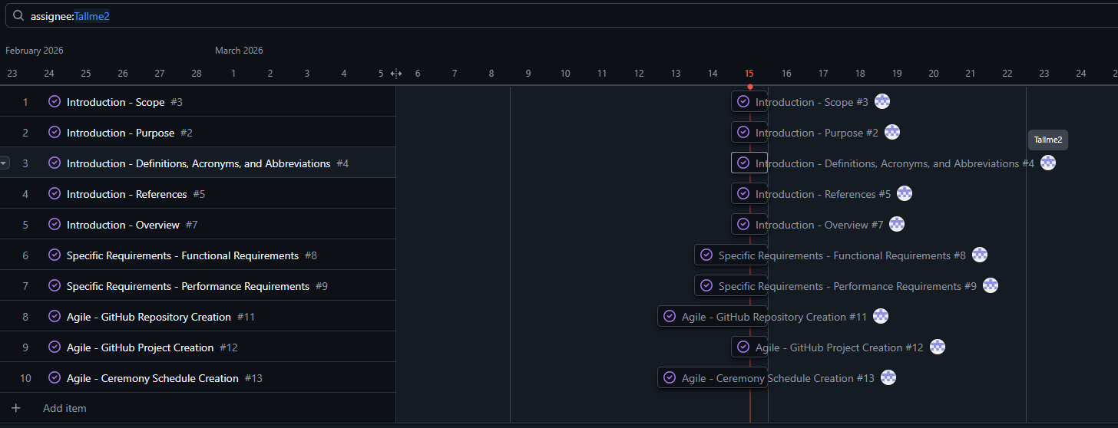

- Hafidzuddin Rizqy Amirullah (Harvey/ZedArray)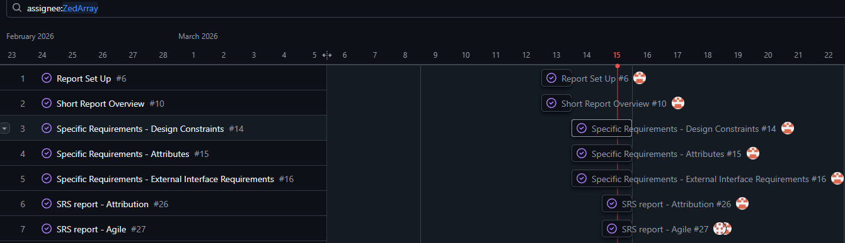

- Pinidu Himsara Kukule Liyanage (piniduliyanage-design)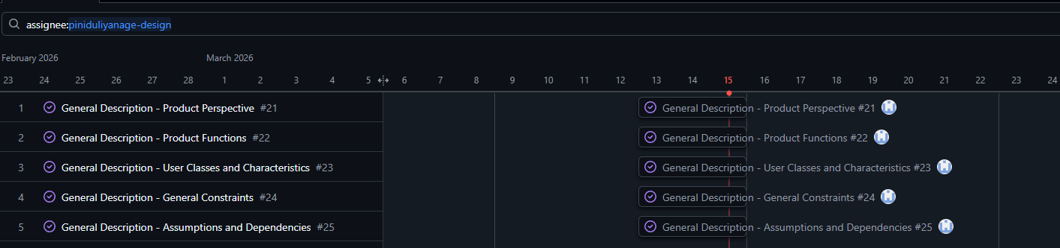

- Charles Jasper Cope (charlesjcope)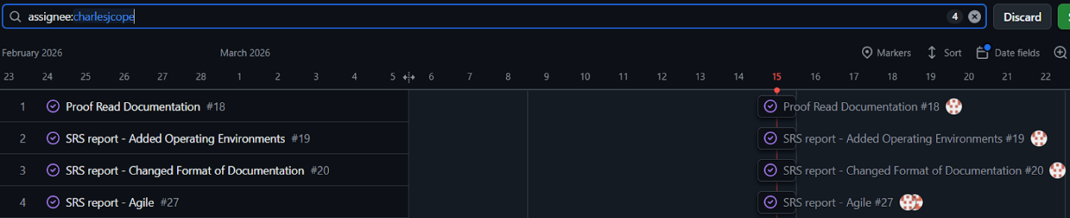

Agile
- Meeting with Client
Minutes workshop w4
- Regular Communications
  - Meeting Minutes

Sprint Planning - Friday
- Discussed the requirements for milestone 1, including marking rubrics, and established the best way to delegate tasks amongst members.
- Tasked individuals with parts to complete of the milestone 1 SRS document.
- Navigated throughout the IEEE framework to address each topic on a surface level collaboratively in order to outline each task and have all members on board.
- Closed out by creating an initial draft for Toggl Track and planning for task tracking and assignment

Catch-up - Saturday
- A short discussion regarding what has been completed so far, expected completion times and requirements

Catch-up - Sunday
- Adjusted the meeting schedule for standups in order to accommodate all members.
- Discussed work completed so far and future prospects for task allocation and timelines.
- Adjusted the tracking board from Toggl Plan to DevOps projects in order to construct a burnup plan.
- Progress tracking
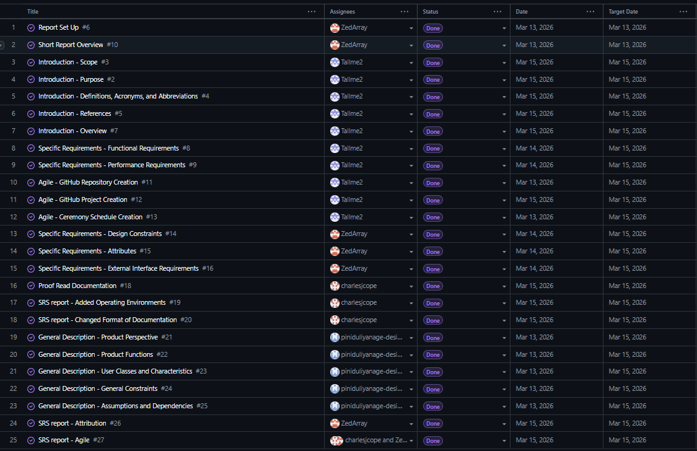

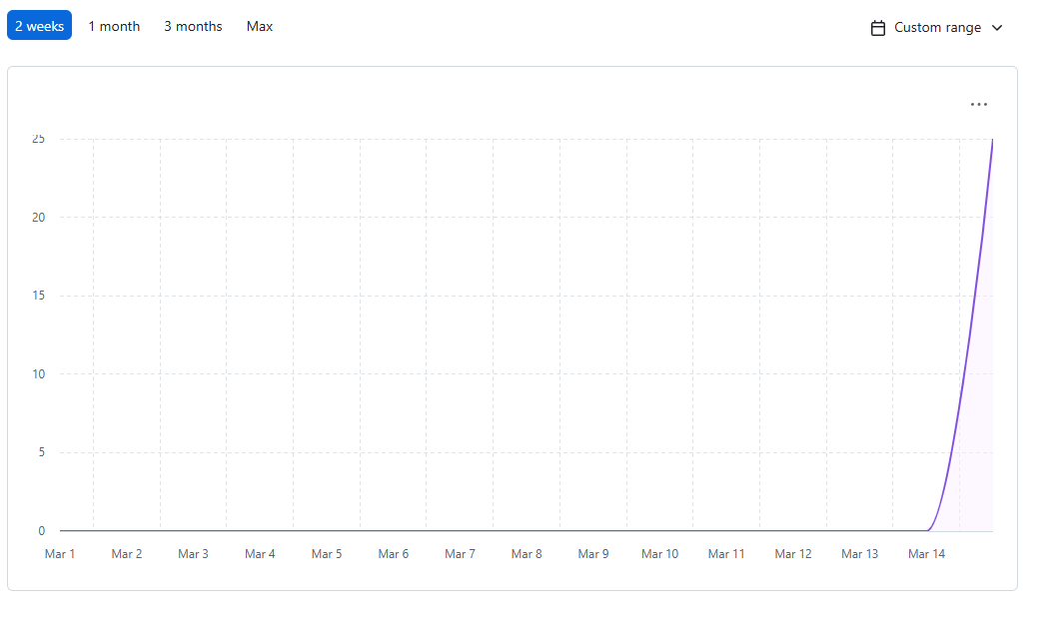
- Our team worked together to complete a total of 25 features for this milestone, where most of these features are of the SRS, which follows the IEEE guide for SRS.
- The burn-up chart appears irregular because we moved onto GitHub Projects from Toggl Plan late in the development process, which caused some of our work recordings to be lost
- Overall, we were just on target. However, as a team, we think we worked efficiently together as we finished this sprint within only three days.
- In reflection, an earlier team meeting to allocate key aspects of the report would have improved our schedule and reduced last-minute pressure.

